© [Rozetka.com](https://bt.rozetka.com.ua/ua/tehnika-dlya-kuhni/c435974/)

Test plan

Rozetka/technic for kitchen

Product: Rozetka/technic for kitchen

Author: Hennadii Prokopenko

Approvals: Kiril Katasonov

Version 1.0

Create: 31/01/2023

Status: Draft

**1. INTRODUCTION**

**1.1 Project Overview**

**Rozetka** is an online store for household appliances and other goods.

**1.2 Initial data**

1.2.1 Main functionality:

* Account registration;
* Buy;
* Buy on credit;
* Add to Favorites;
* Placing an order (entering contact details; delivery; payment)

1.2.2 Functional part:

* Sort;
* Filters;
* Range (min/max);
* Add to Favorites (add-remove);
* Buy/Buy on credit (Add-remove to Cart; edit amount of product);

**1.3 Testing purpose**

The purpose of testing is to test all functionality according to the initial data.

**1.4 Entrance and exit criteria**

**1.4.1 Entrance criteria**

* According to homework №12.
* Create the test documentations (test cases on [Qase](https://app.qase.io/projects)) according to the selected testing approaches.

**1.4.2 Exit criteria**

* According to deadlines.
* Tests should cover 90% of the basic functionality according to the initial data.
* All tests passed. Created bug reports for all found bugs.
* If no bugs are found, then testing finishes upon the test execution complete.

**2. TEST STRATEGY**

**2.1 Testing strategy steps**

The test strategy will be as follows:

* The first stage consists in drawing up a general test plan and test cases, in the context of the selected testing approaches. The result of the first stage is the coordination of the test plan and test cases with the manager.
* The second stage will consist of functional testing according to the initial data. Functionality will be tested using Ad-hoc, Smoke testing. The Smoke testing will include security testing and performance testing. The result of the second stage will be the passage of the ad-hoc, smoke test, including security and performance testing. The creation of bug reports, If the bugs are found. The results must be agreed with the manager.

**2.2 Testing workflow**

**2.2.1 Functional testing**

Functional testing will be performed to check the functions of program. Function testing will be performed using Ad-hoc and Smoke, including Security and Performance testing.

The cycle of security tests is designed to assess the vulnerability of software to various attacks.

The cycle of performance tests is designed to check the speed of procedures, stability, reliability and scalability of the system as a whole.

The test cases according ad-hoc, smoke, security, performance is created in the Qase program at the links: <https://app.qase.io/public/report/077efe712ad765722308978419a4bb130e47f9e6>

**2.3 List of jobs and deadlines**

|  |  |  |  |
| --- | --- | --- | --- |
| **№** | **Job types** | **Author** | **Due date** |
| 1 | Test plan | Hennadii Prokopenko | 31.01.2023 |
| 2 | Create Functional Test Cases: | Hennadii Prokopenko | 03.02.2023 |
| 2.1 | Create Ad-hoc Test Cases | Hennadii Prokopenko | 01.02.2023 |
| 2.2 | Create Smoke Test Cases | Hennadii Prokopenko | 02.02.2023 |
| 2.3 | Create Security Test Cases | Hennadii Prokopenko | 02.02.2023 |
| 2.4 | Create Performance Test Cases | Hennadii Prokopenko | 03.02.2023 |
| 3 | Create Bug-Reports in Jira | Hennadii Prokopenko | 04.02.2023 |

**2.4 Software product development methodology**

Scrum was chosen to implement the project.

**2.5 Daily Standup**

Daily Standup lasts 25-40 minutes on the daily.

Team consists of:

1. Anton Pilipenko
2. Hennadii Prokopenko
3. Nataliya Tkachuk
4. Dmytro Shkarivskyi

**2.6 Priority**

Task priorities according to scrum board in Jira: <https://prokopenkoga.atlassian.net/jira/software/c/projects/Q2R/boards/9?selectedIssue=Q2R-6>

**2.7 Test execution process**

Create the test cases in Qase

Create Bug-Reports in Jira (if a bug will be found)

Complete the

test execution of

all the test cases

Mark Status as Pass/Fail in Qase

Execute each of the test step in test case

**2.8 Test environment**

A windows environment with Internet Explorer 8, 9 and 10, and with Google Chrome32.0 and later should be available to each tester.

**Results of testing:** <https://app.qase.io/public/report/077efe712ad765722308978419a4bb130e47f9e6>

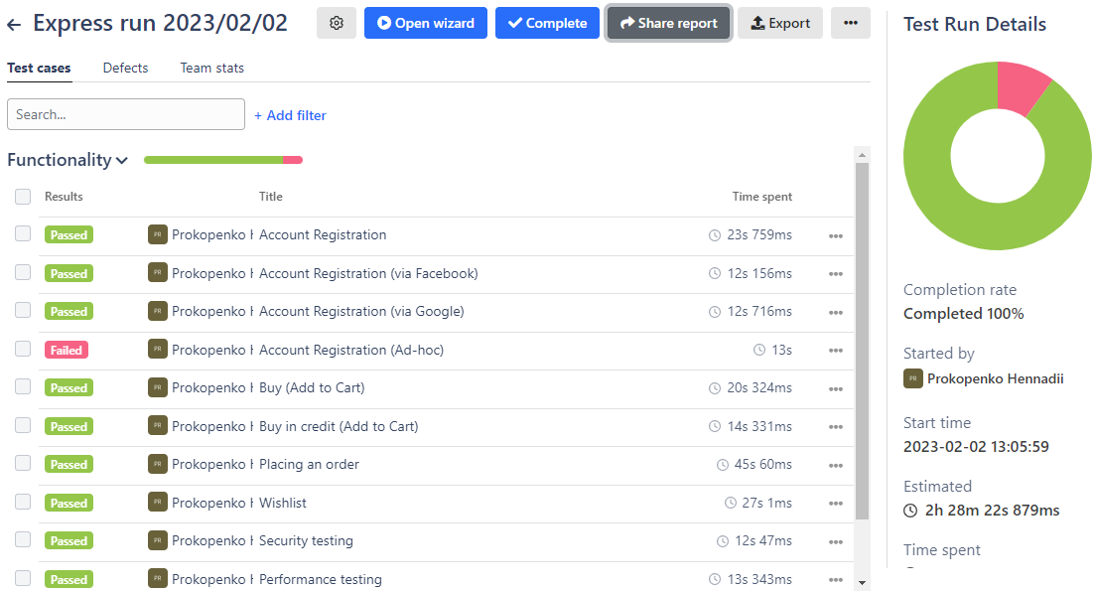

**Project in Jira:** [**https://prokopenkoga.atlassian.net/jira/software/c/projects/Q2R/boards/9?selectedIssue=Q2R-6**](https://prokopenkoga.atlassian.net/jira/software/c/projects/Q2R/boards/9?selectedIssue=Q2R-6)

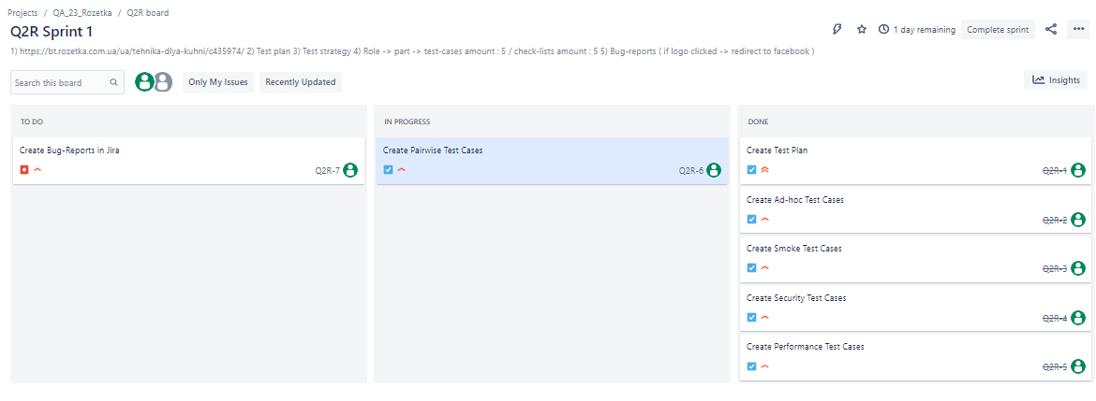

**Bug reports:**

1. [**https://prokopenkoga.atlassian.net/browse/Q2R-7?atlOrigin=eyJpIjoiZTZhMjc1NGMzMjhmNDQ3MThkYTAyN2ViYTg4MzQ4YzAiLCJwIjoiaiJ9**](https://prokopenkoga.atlassian.net/browse/Q2R-7?atlOrigin=eyJpIjoiZTZhMjc1NGMzMjhmNDQ3MThkYTAyN2ViYTg4MzQ4YzAiLCJwIjoiaiJ9)

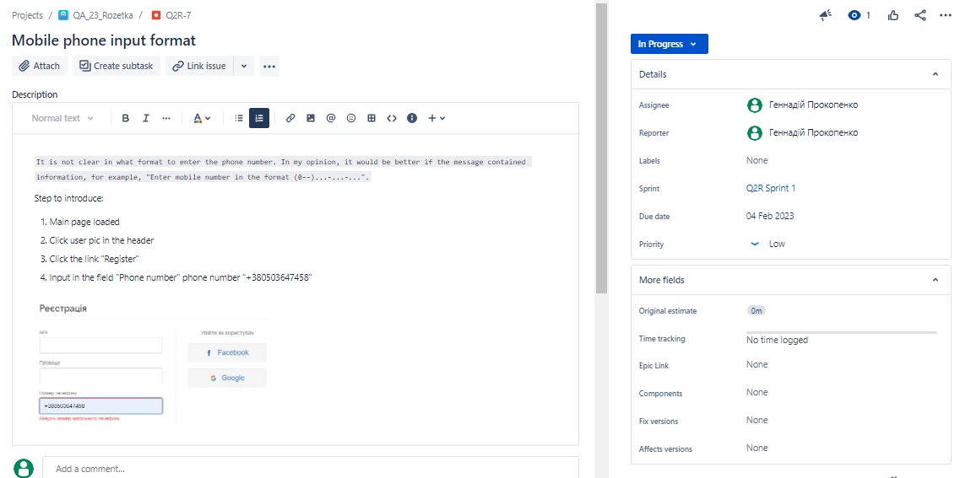

1. [**https://prokopenkoga.atlassian.net/browse/Q2R-8?atlOrigin=eyJpIjoiMjU5YjQyMWMzNjJiNGMxZmI2ZTBjMDE0NDE2OGUzYmYiLCJwIjoiaiJ9**](https://prokopenkoga.atlassian.net/browse/Q2R-8?atlOrigin=eyJpIjoiMjU5YjQyMWMzNjJiNGMxZmI2ZTBjMDE0NDE2OGUzYmYiLCJwIjoiaiJ9)

